Electromyography (EMG) Lab

An electromyograph is an instrument which can record electrical activity produced by skeletal muscle when it is stimulated to contract. Electrical signals travel down the motor neuron to the muscle, and these electrical signals can be recorded and analyzed. This can be a useful clinical procedure in identifying neuromuscular dysfunction.
Skeletal muscle is also called voluntary muscle, because we can “voluntarily” move this type of muscle. Most skeletal muscle is attached to bones, and when this type of muscle is stimulated to contract, the bones move. Skeletal muscle consists of many individual muscle cells, called fibers, and these cells must be stimulated to contract by a neuron, called a motor neuron. Motor neurons begin in the brain or spinal cord, and travel out to the muscle where the nerve fiber branches out to stimulate many muscle fibers. The motor neuron and the muscle fibers it stimulates are together referred to as the motor unit. When the motor neuron sends an electrical signal (action potential), it will stimulate all of the muscle fibers that are part of that motor unit.
The number of motor units differs in between the skeletal muscles in our body, and an individual muscle will have both smaller and larger motor units within itself. Smaller motor units will produce weaker contractions than a large motor unit. Activating a small vs large motor unit depends on how precise the movement needs to be or if the movement needs to be forceful but not very refined.
When a task is required such as lifting a heavy object, the smaller motor units in the muscles required for lifting are stimulated first. The brain receives sensory information from stretch receptors in the muscle, tendon and joint capsule. If adequate power is not developing, the brain activates additional motor units until the sensory feedback information indicates the object is lifted. This activation of more motor units is called recruitment.
Once you have lifted the object, the brain recruits approximately the same number of motor units to keep it lifted, but cycles between different motor units. This allows some motor units to relax and replenish ATP while other motor units are contracting. Eventually, skeletal muscles will fatigue and contraction strength will fall.
Resting muscles are not usually completely relaxed, but exhibit a constant state of slight activation that helps to maintain readiness, posture and body temperature. This resting tension is called muscle tone. Muscle tone is achieved by periodic activation of a small number of motor units.

To summarize, the degree of skeletal muscle contraction is controlled by three factors:
- The frequency of action potentials to the muscle cells. More frequent action potentials in a motor unit will make it contract more often.
- The number of motor units activated. Stronger contractions result from activating more motor units (recruitment).
- The size of motor units activated. The smaller motor units in a muscle are activated first, with progressively larger motor units activated until enough forced is produced to obtain the desired movement.
Objectives
In this experiment you will:
- Observe and record skeletal muscle tone at the minimal activation level of electrical activity during the resting state.
- Record the maximum clench strength and electrical signal produced and compare either right and left arms or one person to another.
- Observe, record, and correlate motor unit recruitment progressing from small slow twitch motor units to larger fast twitch motor units with increased power of contraction.
- Observe the effects of fatigue on a muscle and the resulting changes in the EMG.
Procedure
Log onto the computer at your lab table.
- Click on “Logger Pro 3.8.4” icon on the desktop.
- Under “File – Open”, click on “ Human Phys with Vernier – EMG & Muscle Fatigue”.
- Find the hand dynamometer in your box.
- Follow the instructions “Using the Hand Dynamometer” included in your kit for “grip strength” to see how to hold the hand dynamometer.

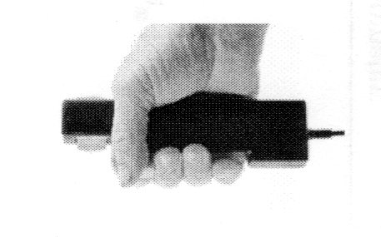

- Connect the Hand Dynamometer to the LabQuest Minibox.
- Connect the LabQuest Minibox to a USB port in the computer.

- Attach 3 electrode tabs to one of your arms as shown in Fig. 3. Attach the green and red leads to the tabs on the forearm (they are interchangeable). Attach the black lead to the upper arm.

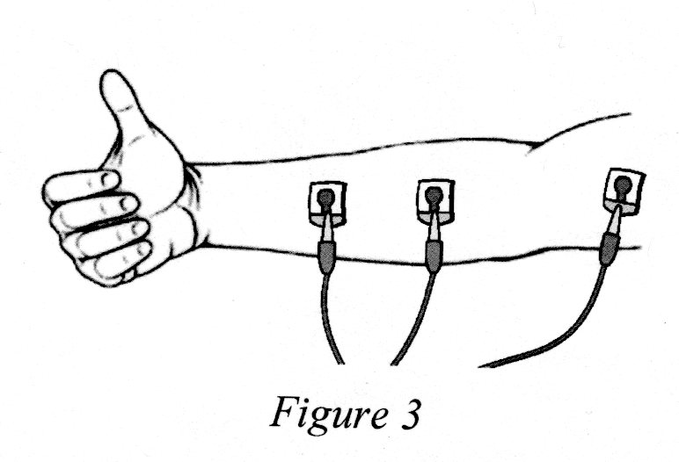

- Put leads into labquest minibox.
- Subject should sit with back straight, feet on floor, elbow at 90 degree angle and arm unsupported.
- Determine maximum grip strength by gripping the hand dynamometer with full strength. Read force amount from graph. Round to the nearest number. Calculate 25%, 50%, 75% of your full grip strength.
- Click on the green “collect” tab on the top toolbar, and then squeeze the Dynamometer to 25% maximum strength, hold for a few seconds, relax. Grip strength to 50% of maximum strength, hold for a few seconds, relax. Grip strength to 75% of total strength, hold for a few seconds, and relax. Grip to full strength, hold for a few seconds, then relax. Grip once more to full strength, and hold until your muscle fatigues. As you are fatiguing, have your lab partners encourage you to hold longer.

To analyze data:
Click on “stat” on the top toolbar. Place the cursor at the beginning of the peak on the top graph, where the force from your 25% grip strength was recorded. Click and drag the cursor over the contraction peak to the end of contraction. A box should pop up which has the statistics for that contraction cycle. Record the data in the table below:

Forearm 1 (dominant arm) |  | Forearm 2 (non-dominant arm)
 | Max value | Max value
Grip strength
25%
50%
75%
100%

Repeat above procedure with your non-dominant arm, or have another person record data for their grip.
Data Analysis
Using the “Maximum value” measurement from the table above, calculate the percentage increase in EMG activity between the weakest grip and the strongest grip of forearm 1. Repeat the calculation for forearm 2.
% increase = (largest max – smallest max)
X 100
Smallest max

Forearm 1 % increase:

Forearm 2 % increase:

Compare the maximum EMG for the right and left grips. Are they different?
Which is larger?
Was the arm with the larger signal stronger?

What other factors may affect the size of the EMG signal besides strength of the muscle?

What is the source of the signals detected by the EMG electrodes?

Define motor unit recruitment:

What is skeletal muscle tone, and what purpose does it serve?

Set up the EMG for another student. Hit “collect” to record new data.
Relax your grip muscles so there is no activity visible on the EMG. Now gradually increase your grip just enough that you only see a few spikes on the EMG. Each spike indicates the activation on one motor unit.
What is a motor unit?

Is each spike an action potential from one muscle fiber?
Why are some spikes larger than others?

Can you pick out a specific motor unit (a spike that is always the same height) that is activated repeatedly? Why does this motor unit only appear at certain times? Consider two reasons:

Gradually increase the activation of the grip muscles so that more activity occurs on the EMG. You are now recruiting more motor units.
Do the spikes get taller, more frequent, or both?

Earlier we discussed three ways to increase the strength of contraction.
- Send more frequent ______________________________to motor unit to contract them more frequently.

- Recruit ______________ motor units if more force is needed, and if still more is needed—

- Recruit the ____________________ motor units.
Lastly, squeeze the hand dynamometer as hard as you can and hold this maximum contraction. Watch the EMG as your muscles fatigue.
What happened to the height of the EMG signal when you increased grip strength?

Did it stay high as your arm fatigued?

Which motor units were dropping out (fast or slow twitch)?

Did they come back in again at times?

Which metabolic pathway were these fibers using to produce ATP?

What are the byproducts of this type of metabolic pathway?

Which motor units continued to function? Which metabolic pathway do these fibers use to produce ATP?

What are the products of their metabolic reactions?

What are some anatomical differences which allow this type of muscle fiber to contract longer?

